**Experiment Tracking**

1. ML Flow code has been added to log the parameters and metrics
2. Three different model run has been done.

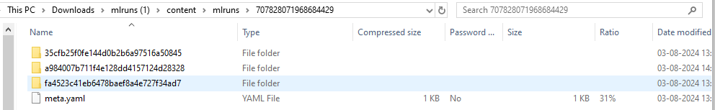

1. Each run has the following:-

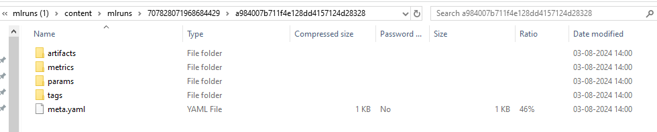

**Data Versioning**

1. Initializing the DVC in the git repo.

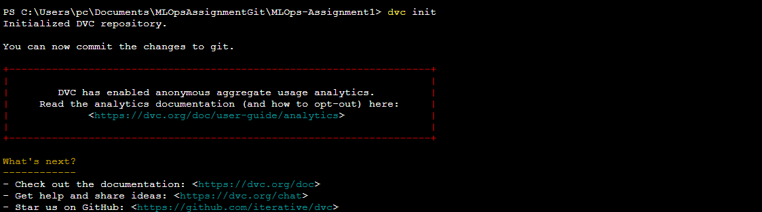

1. Once dvc is initialized then .dvc and .gitignore gets created.

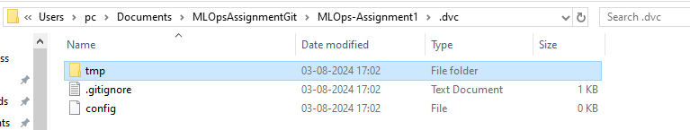

1. Adding the current data to the DVC



1. Once the data gets added then .dvc file gets created for the data. A version having the metadata of the original file gets created.

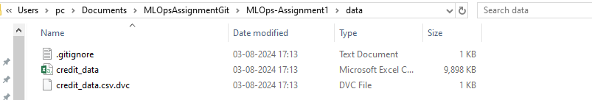

1. We try to do a change in one line of the source file and do a commit. Then 2 versions of the file gets created.



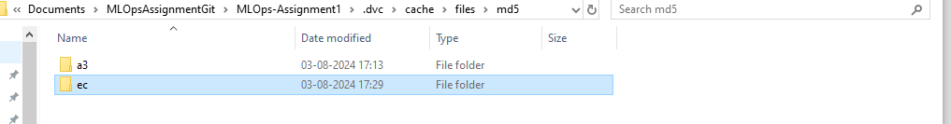

1. To revert it to the previous version give the following command
2. Git checkout HEAD~1 -b data/credit_data.csv
3. dvc checkout

